Solo: Above or Below the Average?

Introduction – My analysis methods.

I plan on updating this mini-article as I refine my approach, but for now, this will give anyone a good overview as to how I approach my statistical analysis, what statistics I’m using, and what bias I might have.

**Patch and Result stratification**

How a team plays the game has a lot of factors. There might be a player on the opposing team they are looking to shut down, there might be a specific champion combination that allows them to be more/or less aggressive. But often, the way the team plays is dictated by the metagame, which defines the generally available strategies and champions. While a team can choose to play “off meta” and go for some off the wall picks or strategies, it’s just not that common, especially in NA. Unfortunately, it’s hard to take the “meta” into account when looking at statistics, so we’re going to use patch’s to help cover the ‘meta’ factor. Every 2 weeks or so, Riot games releases a new patch, which has the potential to greatly affect the meta. These patches can include champion buffs or nerfs, item buffs or nerfs, and occasionally how xp and gold is collected or achieved around the map.

The week’s patch does a lot to help define the meta, and so it makes sense to use patches to normalize some of the data. I am only going to be using data from patch 8.01 and onward because that is the first patch where Solo was a professional starter. This cuts out some of the noise on reworks and seasonal game changes. If I find that it makes sense to get more granular and group by major patch (8.xx, 9.xx, etc) or even patch to patch, I will do so.

**Data of interest.**

First off, thank you to Oracle’s Elixer for providing extensive and well-manicured data for us to pull from. I have also expanded that data with my own web scraping efforts (which I’ll write about in a separate post). I’d like to thank Riot games for waiting just long enough for me to implement my scraping programs before shutting down the match history website.

The funny thing about statistical analysis is that the stats can say anything you want if you put them in the correct context. From that point of view, it’s important to acknowledge your personal bias or at the very least, the beliefs you have coming into an analysis. Before I get started, I would like to acknowledge a bias I have coming into this analysis:

**There are no good players with aggregate bad stats.** A player who is good at the game, where good is a function of their capability against their peers, is going to have good team percentage stats, regardless of how good or bad their team is. If a player is good, they’re either going to make their own advantages or their team is going to give them resources. At the end of the game, they’re going to have higher than average earned gold share, and probably higher per average damage share. If a player is bad, then they are not going to be able to make their own leads, and their team throwing them resources is only going to put them at or near the average for their position.

Part 0: Beginnings

I will start with a bit of honesty. I began this particular journey in August of 2020, after watching Flyquest devastate my dreams of Cloud9 reclaiming their Spring 2020 Championship form. I remember watching Solo on Shen, cruise to victory and thinking, “how can this be happening, *Solo isn’t even that good*”.

<https://youtu.be/5xZuKb8c2R0?list=PLJIIsW8PQINA5v_ijxPzYygvk7b2MeZcC&t=2604>

It was around the same time that I was semi-employed and dabbling in data analytics tools to keep myself sane (everyone needs a hobby). I thought maybe this would be a great way to exercise these skills and maybe find out what madness led to this world-shaking upset from this middle of the pack top laner.

At the start of 2020, Solo wasn’t even on a starting roster, and while people thought this was odd, it wasn’t a decision that earned anything like the vitriol generated by the teamlessness of native NA midlane players Damonte and Pobelter. It wasn’t until the tail end of the 2020 Spring season that Solo was back in a lineup, and he absolutely shocked the world (ok, possibly just me) by being an absolutely monstrous player for his team. I really didn’t remember him being particularly good before, but here he was, dragging his team kicking and screaming into the NA LCS finals.

So this begs the question, was Solo always a good player? Or has he been held down by the low tier teams he’s been on? He played as a sub in 2016, a starter in 2018 and 2019, and then in the minor (Academy) league for most of the 2020 spring season. Prior to his 2020 runs, his main claim to fame had been… that he didn’t take an import spot. In 2021 he managed to take a dead last place GoldenGuardians and make them… slightly better, before being replaced mid-split.

This article started out simple, and grew to shockingly large proportions as I figured out how deep this rabbit hole could go. Thus what was conceived as a single article has ballooned into the following planned posts.

1. Introduction to Solo and how he stacks up against his peers
2. Solo’s Champion Pool and Team Role
3. Solo’s gameplay against his statistical context.

For part 1, I’m going to look at the bird’s eye view of Solo’s career, and see how he has stacked up against his peers over the course of his career. I’m just going to be looking at the NALCS for this investigation. I want to compare Solo against his peers in order to have the tightest comparative analysis.

Part 1: Solo against the rest of the LCS

First thing I did was pull the basic stats that you hear bandied about on the internet when talking about a player’s performance. How many kills do they get? How much CS do they get? Do they contribute to their team’s damage share? What’s their laning like? I took those stats for Solo specifically and then I took an average of those stats across all of the other LCS top laners. Below is the table of the average “basic” top lane stats compared to Solo’s, with some calculations for whether he is above or below those averages, and then how significant is that difference.

|  |  |  |  |  |  |
| --- | --- | --- | --- | --- | --- |
|  | Toplane Avg | Toplane  Std. Dev | Solo Avg | Solo off of Avg | Std Dev’s from Avg |
| kills | 2.344 | 1.99526 | 2.081 | -0.263 | -0.132 |
| deaths | 2.467 | 1.73312 | 2.781 | 0.315 | 0.182 |
| assists | 4.761 | 3.42119 | 4.619 | -0.142 | -0.042 |
| earnedgoldshare | 0.226 | 0.03388 | 0.228 | 0.002 | 0.067 |
| damageshare | 0.236 | 0.07074 | 0.242 | 0.006 | 0.084 |
| total_cs | 276.121 | 66.8016 | 293.550 | 17.429 | 0.261 |
| dpm | 429.660 | 163.268 | 437.058 | 7.398 | 0.045 |
| gamelength | 2052.504 | 389.617 | 2140.163 | 87.659 | 0.225 |
| totaldamage | 14866.767 | 6849.67 | 15889.556 | 1022.789 | 0.149 |
| goldat10 | 3257.449 | 330.65 | 3293.794 | 36.344 | 0.110 |
| xpat10 | 4526.081 | 356.274 | 4592.588 | 66.507 | 0.187 |
| csat10 | 77.125 | 10.9271 | 81.088 | 3.962 | 0.363 |
| goldat15 | 5166.421 | 586.133 | 5212.563 | 46.141 | 0.079 |
| xpat15 | 7162.824 | 565.796 | 7296.725 | 133.901 | 0.237 |
| csat15 | 123.600 | 15.9602 | 130.306 | 6.706 | 0.420 |
| goldearned | 13099.740 | 3142.55 | 13555.568 | 455.828 | 0.145 |
| damagetaken | 23254.947 | 9332.15 | 26194.233 | 2939.285 | 0.315 |
| totaldamagetoobjectives | 8889.158 | 6998.52 | 8566.582 | -322.576 | -0.046 |

Table 1: Solo vs LCS

Well, there it is. There are Solo’s stats vs all the other LCS toplaners in the patches he’s played on. I see more green than red so I guess he must be good. Case closed.

From a statistical perspective, I actually don’t think these stats are as illuminating as I hoped they would be. While his averages might be a bit above or below the average of all toplaners, they’re above/below by less than a full standard deviation in all cases. Less than a tenth of a standard deviation in many cases. I’ve highlighted the 3 most “significantly different” values but they’re really not that different from his peers. Solo drifts pretty close to the mean and while his numbers are “higher” in many cases, They’re not that much higher. After reviewing this table, I considered dumping it, as there didn’t seem to be much use in data that I don’t think is very illuminating. That being said, I think it represents a good baseline for later evaluation.

Seeing how either average or homogenous this data is, I thought it would make sense to separate it out over his career and see how he’s stacked up year over year. I also wanted to normalize the data in a way that would quickly tell me if there were any standout values. I applied the following formula to a subset of Solo’s stats in order to create a common scale and method of measure.

(Solo Avg – LCS Top Lane Avg)/Standard Deviation of LCS Top Lane Avg

This gives me the number of standard deviations any given value is from the average. I believe this is useful because it tells me not just whether Solo is performing above or below average, but if that performance is a significant departure from the performance of any other play. Anything less than half a standard deviation is basically the average, and even that is fairly inconsequential. If anything is 1 or more standard deviations away from the mean is definitely worth looking at.

The statistics I’ve chosen to use here are as follows:

Damage Taken – The average amount of damage Solo absorbs per game. I’d expect this to be above average on a tank player since it would mean he has a larger health pool in his games.

Damage Share – This is the percentage of his team’s damage that Solo is dealing. I believe this will be generally below average for the same reason I think his Damage Taken will be above average.

Damage Per Gold Earned Ratio – This is a new stat I’m trying out. I took the damage dealt per game and divided it by his earned gold value. This is going to tell me roughly how efficient Solo is at converting gold into damage compares to his peers. I would guess this will also be on the lower side for the same reasons mentioned above.

Kill Participation – KP is the average number of kills that Solo participates in. You can represent this as a percentage or as a number and for now I’m going to use a percentage. This helps prevent it from being inflated if Solo’s team has particularly bloody games.

KDA – This is Solo’s (Kills + Assists) / Deaths. I included it because it’s a common measure for how players are discussed and is good to have available. I don’t love this statistic but I think it’s too commonly used to ignore

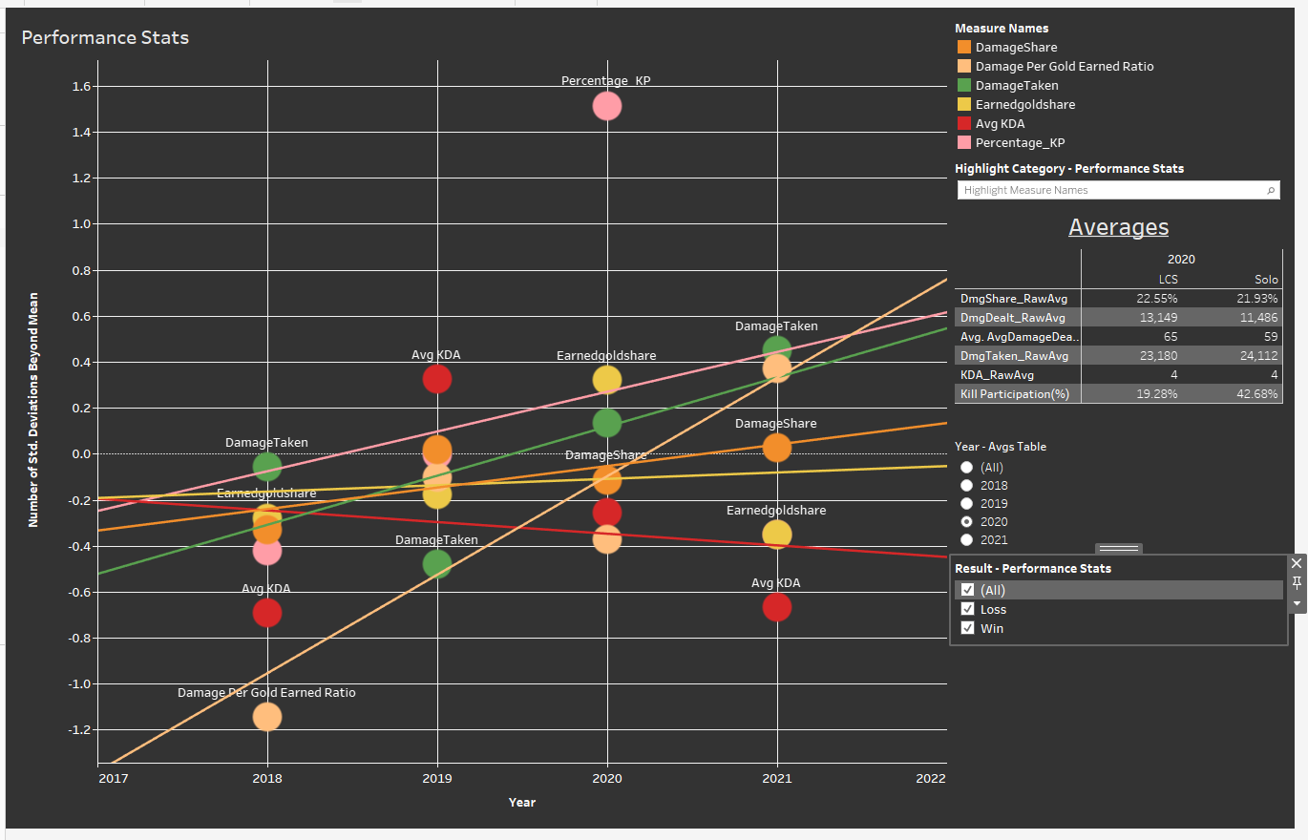

The obvious first things you see is that Solo’s debut year showed him having a horrible lack of ability to convert gold into damage. It’s possible he was on Tank duty 24/7, but even then, his Damagetaken stat is still below average. He did manage to improve that stat significantly over time though. Speaking of improvement, his average Kill Participation is 1.5 standard deviations above the mean in 2020. That’s pretty significant and says a lot about his contributions on FlyQuest’s back to back Finalist runs. I’m going to have to go back and watch his Flyquest games to see if this was a result of his team playing around him, or if he was just pulling a lot of attention. Otherwise I think this chart shows about what I was expecting. Solo’s DamageShare is low and his Earned GoldShare is basically flat and a bit negative. Statistically, Solo has the stat’s I’d expect out of a weak side player who over time seems to have found his groove on tanks (watch that damage taken stat rise).

My biggest takeaway though, is that Solo does in fact show improvement over his career. Everything except his KDA shows a positive trend through the years, and his KDA is going to dip if he’s playing tanks all the time. I’m actually surprised at how above average his 2021 stats look considering he was on some lower-tier teams. I think by the time 2021 came around he was being treated as a veteran on those squads and so even if they weren’t using him as a win condition, they probably played around him more than on previous teams.

I made a second dashboard to show Solo’s Laning statistics, since the first one was starting to feel crowded. For each stat there is his average magnitude at 10 minutes and then the average difference between him and any given enemy laner. Once again I’m using number of standard deviations in order to normalize these stats and help present them against each other.

Here are definitions for the relevant terms:

CS – CreepScore. This is the measure of how many minions you killed. Minions appear in waves of 6 with every third wave having a 7th larger more valuable minion. When you kill a minion you get gold and XP. When a minion dies near you but you don’t get the last hit on it, then you just get the XP.

XP – Experience. This is experience towards your next level. There are 18 levels, each level is worth roughly 500 gold in stats and gives you the ability to either unlock or level up your abilities. You can earn XP without getting the last hit on a minion.

Gold – Gold in League is basically the same thing as it is in real life. Gold is money that you can use to purchase items. Items in game contribute to your stats, enhance your abilities, and sometimes give your bonus abilities of their own. They are very important to the game, though out of scope of most of our discussion.

Diffat10 – Short for “Difference at 10 minutes” this is a measure of the difference in stat between two players at 10 minutes. Example being CS at 10 is how many minions a player has killed at 10 minutes and CS diffat10 is how many *more* minions than their opponent he’s killed. So if Solo’s average CS diff at 10 is 5, that would mean on average he has killed 5 more minions than his opponent.

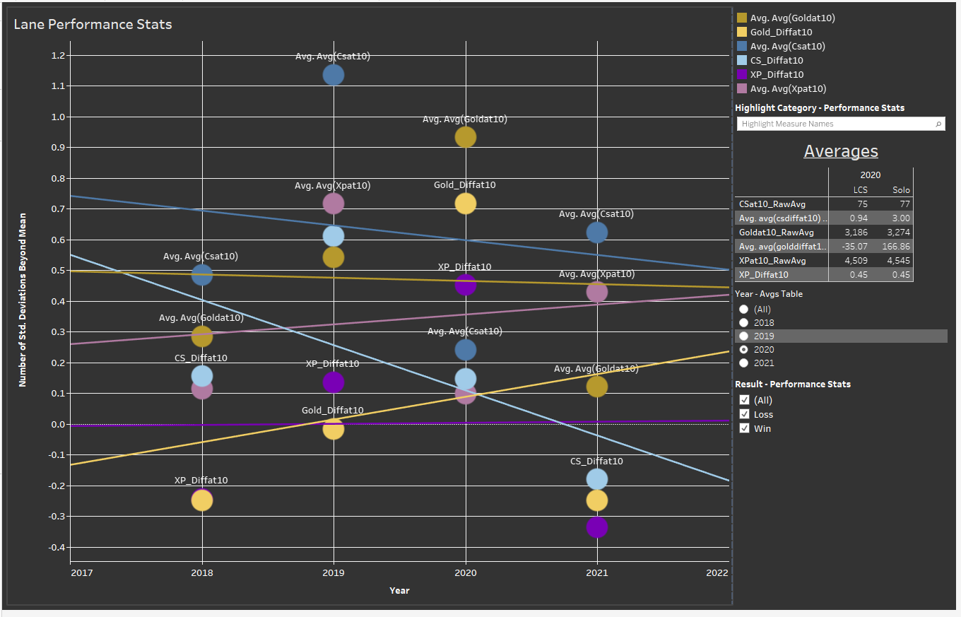

For a weakside tank player, Solo honestly doesn’t look half bad here. He’s positive in avg XP/CS/Gold at 10 across almost his whole career. While it looks like he’s trending down in CS/CSdiffat10, his Gold and XP stats are trending up. I think this probably means that Solo has gotten better at playing weakside. He loses the lane gracefully by staying in XP range and picking up gold/CS under tower, and then he makes it up later with his team play.

I would guess Solo has also learned to die less in lane to early ganks. This would definitely contribute to an upwards trend in gold, since he’s not losing waves to his turret as frequently.

To explore this a bit, I thought I would take a look at Solo’s First Blood stats. I looked at what percentage of games Solo participated in the first blood (either the kill or assist) and what percentage of games he gave up first blood to the enemy (he died). I then compared that to the top lane average to see if Solo was generally above or below average in what I’m calling “Ally vs Enemy First Blood”

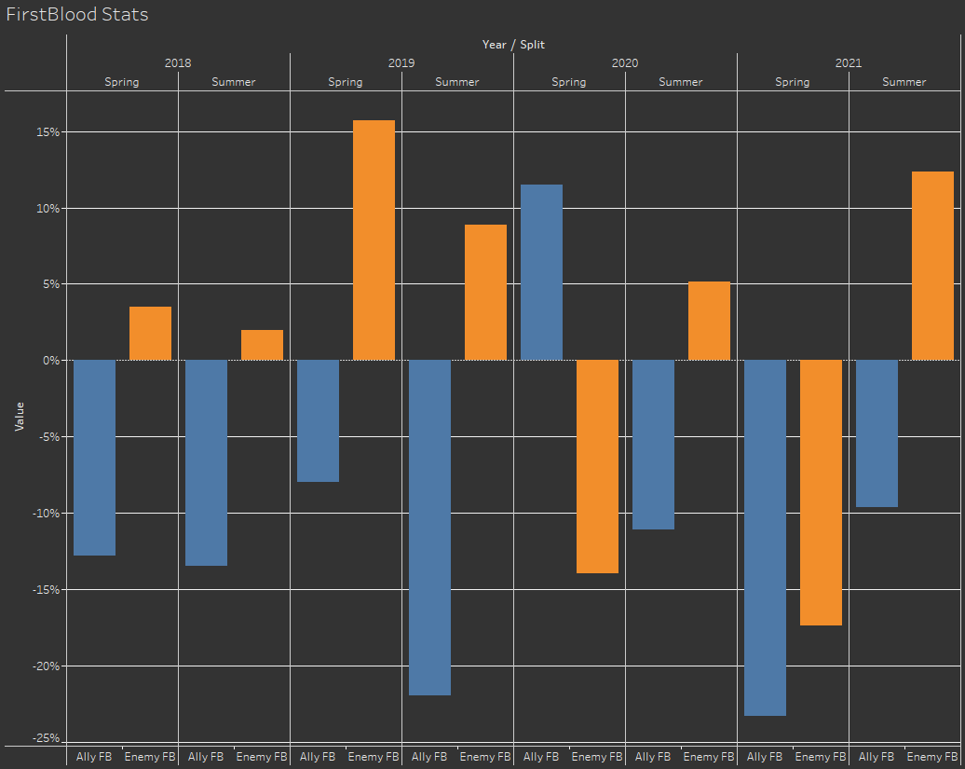

I honestly struggled to find a good visualization for this, so I’ll provide a bit of an explanation. What this chart is showing is that, for example, in Summer 2019, Solo participated in 22% fewer first bloods than the average top laner. Likewise, he was the victim of the first blood kill 9% more than the average top laner.

Well, these stats are interesting. When compared to other top laners, Solo is generally below average in participating in first blood and generally above average in being the victim of the enemy first blood. This persists pretty much throughout his career. While the strength of his team is going to influence this somewhat, even in his best professional year (2020), he was on the wrong sides of the average for Summer, which was the split he played all the way through that year.

Overall I think my hypothesis is incorrect on the XP thing. Solo gets first blooded early quite a bit, and he doesn’t seem to have gotten over that as he’s matured as a player.

This is getting fairly long at this point so I think I’m going to wrap this up here with a nice summary. We’ve characterized Solo as a player who has decent laning stats (despite dying to ganks) and has generally showed an improvement in his team contributions over his career. I expect that as we move into his champion pool and later review his gameplay, we’ll see that this improvement came from finding his niche. Solo I believe is a weak-side player who excels in absorbing pressure for his team without falling too far behind.

**Everything above this is about 2900 words. This is maybe 400 words above average. I think I can probably cut it down but this will make for a good part 1. If I need to add more, split it into 2 parts.**

In comparison to other toplane players, Solo has a fairly small champion pool. You can see here that he tends to be below average in the number of different champions he plays in a split. There can be a lot of reasons for this, mostly based on how his teams want to play, and how his teams want to draft. If Solo’s team needs a stable topside, they’re going to want him to play a bruiser or teamfighter.

**Part 2: Champion Puddle? Champion Ocean?**

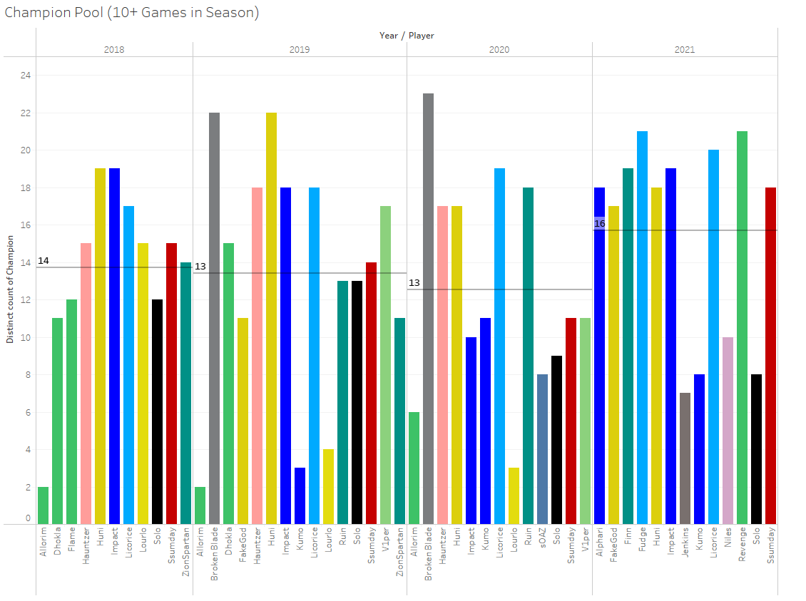

|  |  |  |
| --- | --- | --- |
|  |  |  |
| Champion | Games | PlayRate |
| Ornn | 23 | 14% |
| Aatrox | 21 | 13% |
| Gangplank | 20 | 12% |
| Gnar | 13 | 8% |
| Sett | 13 | 8% |

Table 2: Solo Champ Pool and Play Rate (Patch > 8.01)

Solo’s top 5 most played champions is about what I would expect for someone who doesn’t play a wide variety of champions. It’s the most popular toplane tank (Ornn), a set of bruisers (Aatrox, Sett, Gnar) and a versatile blind-pickable carry (Gangplank). This is a pretty standard collection of top lane champions though notably, it lacks any sort of splitpush hardcarry. No Camille, or Jayce, and Renekton doesn’t even make his top 5. **This probably explains why his DamageTaken is almost 10% higher than the average. Bruisers have large health pools, and their jobs are to absorb damage, so Solo is going to be soaking damage on the frontline more than players who are more likely to be put on high damage champions.**

Additionally, I would wager that Solo rarely gets draft resources from his teams in champ select, nor does he get jungle resources in game. Many of these champs are blind-pickable in LCS meaning that they are difficult to hard-counter without heavy commitment from the other team. Many of these champions would either be a first pick on blue side so as to not give anything away in the draft, or a R3/R4 pick on red side because they are not likely to be counterpicked. That will come later though, I want to do a bit more of an explanation of Solo’s champion pool against the field.

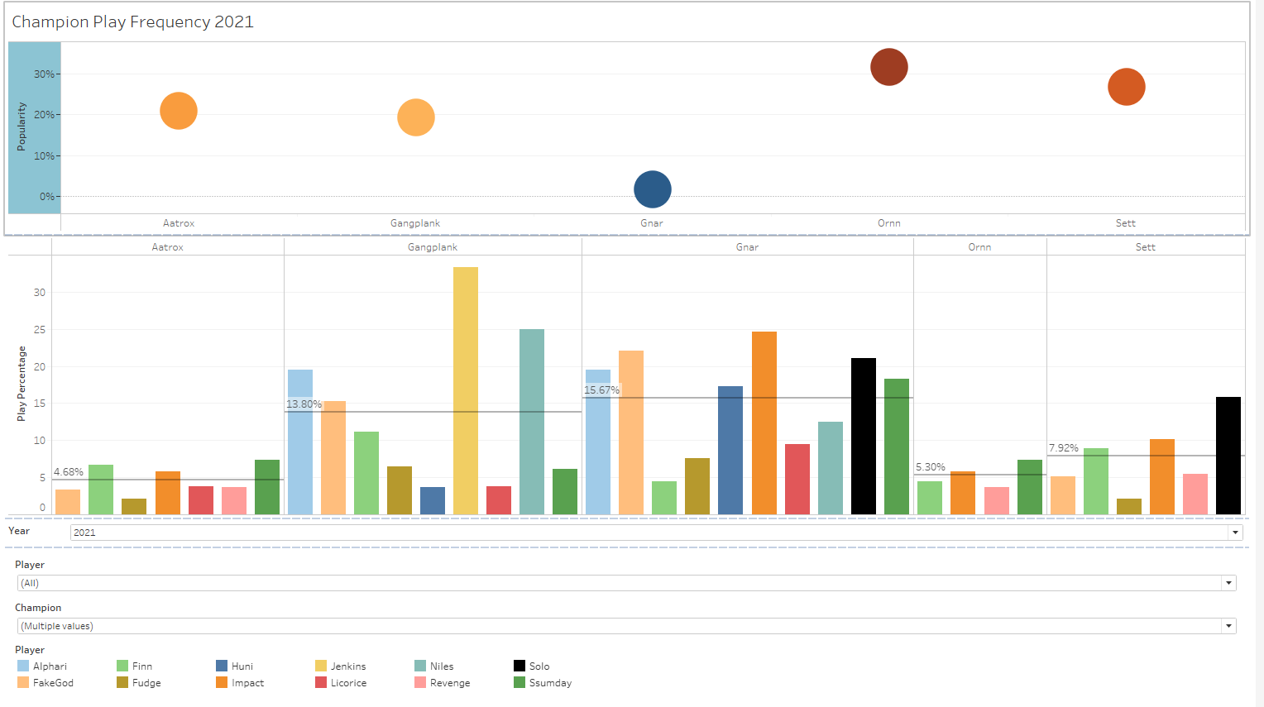

I put together this dashboard to highlight champion play rate tendencies against popularity. The top chart shows how popular the champion was with popularity being defined as their overall pick rate in top lane by year. The bottom chart shows the pick rate of each champion by the players as well as the average player pick rate. The side chart gives a breakdown of which champions each player played and how often in each year.

If a champion is very popular in the top chart that means one of two things. Either teams really want to play it and they pick it early, or it means that it is very safe and you can blind pick it or pick it into a wide variety of champions. That determination will probably have to be made from watching games, but we don’t need it for this part of the analysis.

What I wanted to learn here was whether Solo plays his “favorite” champions at a much higher rate than other top laners, or if he is just playing the high pick rate champions along a particular axis (the best bruiser, the best tank, the best fighter, etc.).

From examining the data, here are some things I learned. Rounding down to the nearest whole champion, Solo is always on the side of having a smaller champion pool than the average top laner.

|  |  |  |
| --- | --- | --- |
| Year | Top Avg Champion Pool* | Solo Avg Champion Pool |
| 2018 | 14 | 12 |
| 2019 | 14 | 13 |
| 2020 | 12 | 9 |
| 2021 | 15 | 8 |

*Excludes players with 2 or fewer games that year

Table 3: Champ Pool Size

Taking 2020 as an example, the top 5 most popular champions were Ornn, Aatrox, Sett, Gangplank, and Renekton. Solo Played Ornn and Sett well above average, and Renekton/Aatrox below average. In a field of bruisers, Solo’s most played champion was a tank, and he played it a disproportionate amount of the time.

In 2019 the top lane pool was almost exclusively high damage carries with one exception. Aatrox, a sustained damage bruiser was the highest presence champion and Solo played it in a third of his games.

Overall, Solo seems to gravitate towards whatever the tankiest option is or Gangplank. He actually plays Gangplank at an above average rate for 3 of his 4 years as a professional player.

**After looking at his champion pool and play rates, I believe that Solo is almost exclusively used as a weak side tank player by his teammates. His job is to absorb jungle pressure and initiate teamfights. When he is forced to blind pick a champion, which I suspect is frequently, he chooses the most popular bruiser, or Gangplank.**

Draft: How does it work?

A quick summary of how draft works in league of legends.

Each team takes turn banning 3 champions (6 champs banned) then there is a round of picks in the following order:

Blue side Pick 1

Red side Pick 1

Red side Pick 2

Blue side Pick 2

Blue side Pick 3

After Blue pick 3, there is another round of bans where each team takes turn banning 2 champions (4 more champs banned for a total of 10 bans) and then there is another round of picks

Red side Pick 4

Blue side Pick 4

Blue side Pick 5

Red side Pick 5.

Because of the pick order, I will be lumping consecutive picks into a single pick, since the other team is incapable of responding between them and they are effectively the same priority level (ex. Red1-2, Blue2-3). When a team picks a champion for a position when they believe they know what champion will be played in the opposite position, that is referred to as a Counterpick. This is an opportunity for a team to try and create a winning lane just based on matchup. The opposite of a counterpick is a blind pick. Blind picks occur when you don’t know what your player will play into, but for a variety of reasons you want to pick their champion before you can have this information. Counterpicks and Blind picks are usually centered around mid lane and top lane since those are the lanes where the 1v1 matchup is most impactful.

When I look at champion select in Solo’s games, here’s what I’m expecting to see:

1. On blue side, he will be given second/third pick because his team will want to get him one of his priority champions and save what counter picks they have available for other lanes. I said previously that a lot of his champion pool would be a blue side first pick to not give away any good info to the enemy team, but I think it’s not likely they will give him first pick outside of metas where the top lane pool is extremely powerful (Spring 2020 might be a time when Sett was first pick).
2. On red side, he will often be Pick 1-2 for the reason stated above, or he will receive 4th pick because his team will want to save their counterpick option for a different lane. Again, I previously said he’s be R3/R4 but I actually think because of his smaller champion pool and the difficulty of punishing a lot of his picks, they will probably pick earlier.

After going through all of Solo’s professional LCS games I found that my general expectation for him was true. Solo received counterpick only about 40% of the time (67 games) and otherwise picked his champion blind.

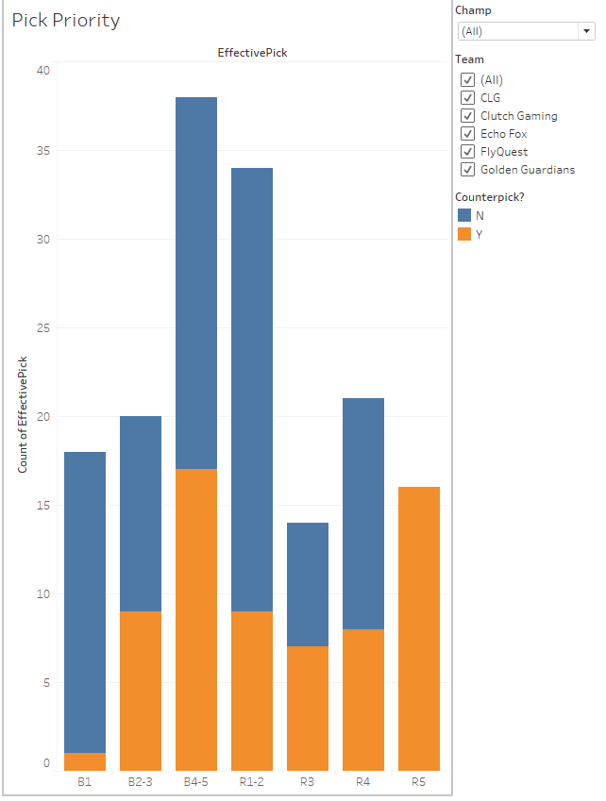

Looking at Solo in the aggregate, I was completely wrong on my Blue side estimate. Solo’s most common pick on blue side was 4-5. Combined with the fact that he wasn’t usually given counterpick, this means that usually Solo was being forced to pick his champion blind, though he was doing it due to his *opponents* draft strategy, since that would mean they commonly saved their last pick for their top laner against him. This makes me think that other teams felt Solo was abusable in lane and worth counterpicking or at the very least they wanted to play around their top laner. This is probably why most of his champions are considered reasonable blind picks, because he plays more than half his games without knowing what he’s going to be matched against.

I assumed because of his smaller than average champion pool, he would most often get his champion on the first set of picks instead of risking his best champions being banned out before the second round. This is making me think that enemy teams haven’t tended to throw a lot of bans Solo’s way, and they aren’t worried about letting him get on “comfort”. That being said, it’s a feather in his cap that his teams aren’t desperately trying to get him a champion all the time in order to make sure he has some impact on the game.

My Red side prediction was pretty spot on. Solo is far and away most commonly R1-2 (40% of his red side games) and when he isn’t R1-2, he’s R4 (25%). Solo is essentially only given counterpick on red side when there is a top laner that is powerful enough that it’s worth first picking by the blue side team. **In other words, Solo is only given counterpick when his team is going to give up a power pick anyways**. Again, this isn’t indicative of a high draft priority going to Solo, and reinforces my belief that most teams use him as a weak side player.

One thing I did notice as I broke down his counterpick percentage is that it actually varied wildly over time

|  |  |  |
| --- | --- | --- |
| Team | Counterpick Percentage | Win Rate |
| Clutch Gaming | 38% | 42.3% |
| Echo Fox | 26% | 30.8% |
| Flyquest | 51% | 59.4% |
| CLG/Golden Guardians | 52% | 31.5% |

I included his win rate to see if there was a correlation and I have to say that there is not. Clutch and Echo Fox were both middle of the pack teams who gave Solo pretty low pick priority. While one might be willing to argue that Flyquest’s high pick priority led to Solo’s best record

**Everything between this and the last blue is about 1900 words which is also a good length for a blog post.**